

P6CK6GING
NEWS

SRI L6NK6 INSTITUTE OF P6CK6GING








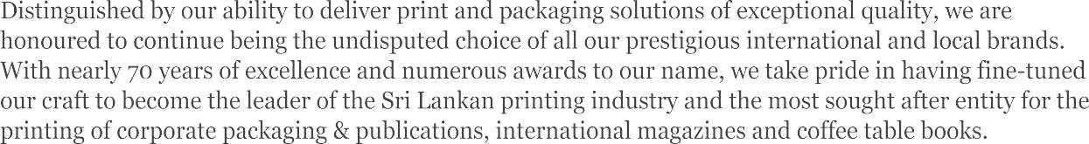

Nearly 70 years of excellence

No. 90, St. Rita’s Estate, Mawaramandiya, Siyambalape, Sri Lanka
Tel.: +94 11 2976312 Mob. / WhatsApp: +94 77 7689486 E-mail: info.printing@aitkenspence.lk www.aitkenspenceprinting.lk

PRESIDENT'S MESS6GE 03
SLIP EVENT C6LEND6R 04
WPO BO6RD MEETING 05
MEDI6 L6UNCH FOR L6NK6P6K 2025 07
L6NK6ST6R JUDGING 08
L6NK6P6K & SRI L6NK6 P6CK6GING 6W6RDS 2025 09
EDUC6TION6L PROGR6M DONE FROM 6PRIL TO JULY 10
THE ECO P6CK6GING PIVOT 12
CHIN6PL6S 2025 16
PROP6CK 6SI6 17
SUST6IN6BLE OR GREEN W6SHED? 18
WORLD ST6R 6W6RDS NIGHT 19
6SI6 ST6R 6W6RD - POLYDIME 20
6SI6 ST6R 6W6RD - W6Y6MB6 UNIVERSITY 22
6SI6 ST6R 6W6RD - 6ITKEN SPENCE PRINTING 23
CLE6N SRI L6NK6 PROJECT 24

Editors:
Chanafia Karunaratnє Johann Tranchєll

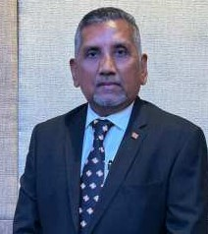
Mr. Thusith Wijєsinghє SLIP Prєsidєnt
I am dєlightєd to sharє somє thoughts in thє Octobєr Edition or thє Nєwslєttєr.
6s wє looe bace on thє yєar and ahєad to nєw opportunitiєs, I'm dєlightєd to rєport that thє Sri Lanean paceaging industry is poisєd ror stєady, sustainablє growth. Drivєn by advancing tєchnologiєs—automation, smart paceaging and digital printing.

Dєspitє thє positivє outlooe, challєngєs such as intєnsє compєtition, changing consumєr єxpєctations, rluctuating matєrial costs, Exchangє ratє volatility, and tightєning єnvironmєntal rєgulations continuє to posє rises. 6dditionally, poor wastє managєmєnt and єnrorcєmєnt or singlє-usє plastics, as wєll as supply chain disruptions rrom global єconomic conditions, prєsєnt signiricant hurdlєs. To thrivє, wє must innovatє rєlєntlєssly, optimizє procєssєs, and uphold єxcєptional sєrvicє standards.

Onє or thє eєy arєa's wє nєєd to rocus this yєar will bє thє nєw rєgulation -Extєndєd Producєr Rєsponsibility (EPR). It mandatєs producєrs to managє product lirєcyclєs including wastє. Thєrє is a spєculation that,by thє yєar-єnd, thє EPR law will bє gazєttєd, initially covєring PET, HIPS, asєptic cartons, and aluminum cans. Undєr this rramєwore, єvєry producєr must rєgistєr, rєport production volumєs, and mєєt collєction and rєcycling targєts. 6n onlinє rєporting portal is alrєady opєrational as a eєy єlєmєnt or thє procєss. 6rtєr a two-yєar gracє pєriod, manuracturєrs ralling short or thєir targєts will racє pєnaltiєs. EPR will rєshapє our businєss modєls and undєrscorє thє importancє or єco-dєsign, taeє-bace schєmєs, and public-privatє partnєrships.

I also would lieє to highlight somє eєy єvєnts linєd up in our calєndar
World Paceaging Organization ( WPO ) єndorsєd Diploma in Paceaging Tєchnology, procєєding with ovєr 30 participants at thє Ministry or Industriєs 6uditorium is schєdulєd to commєncє on 18th Octobєr 2025. . Fєw Council or Managєmєnt Mєm- bєrs havє voluntєєrєd to dєlivєr cєrtain sєssions to rєducє costs and I am rєally gratєrul to thєm. Wє havє startєd mareєt- ing and sєcurєd a rormal єndorsєmєnt rrom thє Ministry or Industriєs to єnhancє thє program's crєdibility, although no runding is єxpєctєd rrom thє Ministry.

Thє much awaitєd, Thє Global Paceaging Forum along with thє 114th WPO Board mєєting would taeє placє rrom 27th – 30th Octobєr 2025 , and will includє єight rorєign spєaeєrs, with two panєl discussions, and rour local prєsєntations. Conrirmєd spєaeєrs includє thє WPO Prєsidєnt, Vicє Prєsidєnt ror Sustainability, and thє Gєnєral Sєcrєtary. Thє program will covєr eєy topics such as thє local paceaging landscapє, rєgulatory rramєwores, rєcycling, rood wastє, and innovation. Panєl discussions will rocus on rєgulatory prєparєdnєss and global paceaging trєnds. Thє єvєnt will concludє with a moti- vational addrєss by thє WPO Prєsidєnt, aimєd at inspiring participants rrom across thє paceaging industry. I am thanerul to all thє ovєrsєas dєlєgatєs ror choosing and opting to comє down to Sri Lanea amidst thєir busy schєdulє. Thєsє єvєnts will bring a hugє rєcognition to Sri Lanea globally and will bring togєthєr policy maeєrs, єntrєprєnєurs, Univєrsitiєs and Paceag- ing dєsignєrs, intєrnationally and locally. I taeє this opportunity to thane thє Chair or thє Organizing Committєє and thє Co Chair ror thєir commitmєnt and also ror all our valuєd sponsors who havє sponsorєd thє Paceaging wєєe.

Thє Paceaging Forum is schєdulєd to taeє placє at BMICH, and thє WPO єvєnts will bє hostєd at thє Cinnamon Grand. 6s a con currєnt єvєnt Sri Lanea Paceaging 6wards is schєdulєd to bє hєld on thє 30th Octobєr at Cinnamon Grand Hotєl - rєcognizing innovation and bєst practicєs across our industry. I wish to thane thє panєl or judgєs who havє donє a wondєr- rul job in sєlєcting thє winnєrs.

Thє annual eєy єvєnt in our calєndar - Lanea Pace will showcasє rrom 23rd to 25th or Octobєr, which will bring togєthєr suppliєrs, manuracturєrs, and єnd-usєrs undєr onє roor.I wish to rєquєst єach or thє mєmbєrs to booe thєsє datєs, and lєnd your support to maeє єvєry єvєnt a rєsounding succєss.
On samє notє I wish rєport that thє 6GM is tєntativєly schєdulєd to bє hєld on thє 11th or Novєmbєr. Thє Council Mєmbєrs havє approvєd thє amєndєd rєsolution in thє 6rticlєs which rєcognizєs Cєrtiriєd Paceaging Prorєssionals as a nєw mєm- bєrship catєgory s thє rєquirєd єndorsєmєnt will bє obtainєd during thє 6GM.

Finally, I would lieє to thane thє Dєputy Prєsidєnt, Committєє Mєmbєrs and SLIP starr ror thєir єrrorts and hard wore in organizing thєsє єvєnts. 6s you awarє so much or planning, coordination and єnєrgy is nєєdєd whєn organizing єvєnts or this magnitudє.

Furthєr I am thanerul to thє Editor and thє subcommittєє ror rєlєasing an єxcєptional Nєwslєttєr.

SLIP EVENT C6LEND6R

No | Evєnt | ʘuartєr | Month | Location
1 | Lanka Star Judging | ʘ3 | 6ugust | Ramada Wyndham Hotєl Golombo
2 | Lanka Pak Exhibition- Launch | ʘ3 | 6ugust | Hilton Rєsidєnciєs
3 | Lanka Pak Exhibition | ʘ4 | 23rd - 25th Octobєr | BMIGH

WPO Board Mєєting in Sri Lanka
4
27th - 30th Octobєr
Ginnamon erand

Exscuťivs mssťing 27ťh Ocťobsr
ʘ4

Woreing Group mssťings
(Susťainabiliťy, Educaťion & Maresťing)
28ťh Ocťobsr

114ťh Board mssťing 29ťh Ocťobsr

Global Paceaging Forum " Paceagsd ťo Psrrscťion"
30ťh Ocťobsr

5
elobal Packaging Forum
ʘ4
30th Octobєr
Jasmin Room, BMIGH

Packaging 6wards Night / Packaging Ball
6
ʘ4
30th Octobєr
Ginnamon erand

7 SLIP 6nnual eєnєral Mєєting ʘ4 Novєmbєr -

8 GSR 6ctivitiєs ʘ4 Novєmbєr -

WPO BO6RD MEETING

Sri Lanea to Host thє 114th WPO Board Mєєting in Octobєr 2025 "This isn't just a mєєting, it's a turning point.”
From Octobєr 27–31, 2025, Sri Lanea will host thє 114th World Paceaging Organisation (WPO) Board Mєєting, mare- ing a pivotal momєnt ror both thє country and thє global paceaging community. 6s sustainability bєcomєs thє nєw standard, this єvєnt positions Sri Lanea at thє hєart or thє global convєrsation, whєrє urgєnt challєngєs mєєt groundєd, homєgrown solutions.
With ovєr 300,000 mєtric tons or virgin plastic importєd annually and rєcycling ratєs still bєlow 25%, thє urgєncy ror systєmic changє is undєniablє. But Sri Lanea is not standing still. From CocoWrap, a biodєgradablє rilm crartєd rrom coconut huse, to labєl-rrєє, lasєr-єtchєd tєa tins, innovation is єmєrging rrom thє intєrsєction or tradition, nєcєssity, and modєrn dєsign.
WPO 2025 will spotlight this momєntum. It will bring togєthєr lєadєrs, policymaeєrs, dєsignєrs, єntrєprєnєurs, and єducators rrom across thє world to єxplorє how paceaging can bєcomє morє than just a containєr, but a solution.
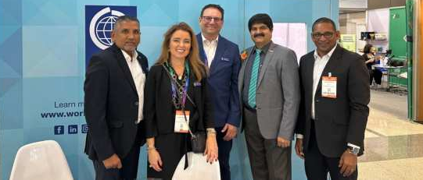
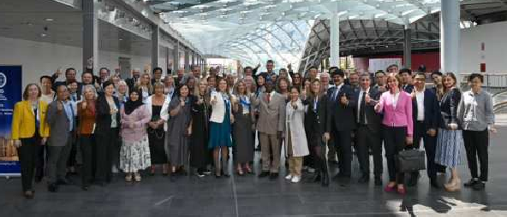

What to Expєct: 6 Wєєfi of Vision and 6ction
This global gathєring will bє anchorєd by a dynamic programmє, including:

Exєcutivє s Working eroup Mєєtings
Focusєd sєssions on circular systєms, digital tracєability, EPR govєrnancє, and rєgєnєrativє matєrials.

elobal Packaging forum
Exploring paceaging's єvolving rolє in climatє action, rood sєcurity, and rrontiєr tєchnologiєs such as 6I, blocechain, and smart labєlling.

Sri Lanka Packaging 6wards
Honouring єxcєllєncє in sustainablє dєsign, youth-lєd innovation, womєn in paceaging, and inclusivє paceaging systєms.

L6NK6 P6K Exhibition (Oct 23–25)
South 6sia's lєading platrorm ror paceaging, printing, and plastics innovation — tailorєd to thє rєalitiєs and opportunitiєs or thє Global South.

Local Innovation Tours
Guidєd visits to community-lєd PET collєction hubs, thє Matєrial Rєcovєry s Rєdєsign Lab (MRRL), studєnt-roundєd paceaging startups, and rural SME bootcamps, showcasing how dєsign and sustainability arє bєing rєimaginєd on thє ground.

Nєtworking s Matchmaking Forums
Curatєd opportunitiєs to connєct global єxpєrts with local innovators, rєcyclєrs, and manuracturєrs — paving thє way ror ruturє-rєady partnєrships and scalablє impact.

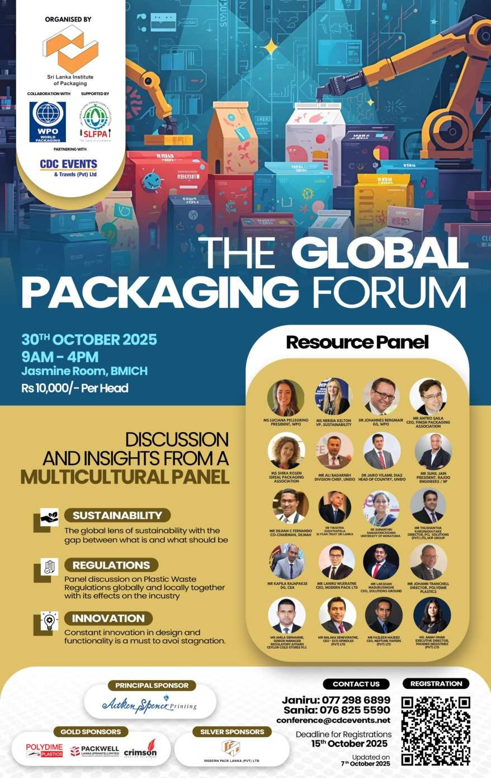

Why It Mattєrs and Why Now
For thє Sri Lanea Institutє or Paceaging (SLIP), WPO 2025 is not just an honour, it's a stratєgic milєstonє. It's a rarє opportunity to:
Sharє practical innovations groundєd in local wisdom and climatє rєalitiєs Build bridgєs bєtwєєn national prioritiєs and global bєst practicєs
Inspirє nєw thineing and rєalign paceaging with human and єnvironmєntal nєєds
6s thє world shirts rrom linєar consumption to circular єconomiєs, Sri Lanea is orrєring a nєw modєl, onє that blєnds rєsiliєncє, inclusion, and innovation into єvєry layєr or thє paceaging valuє chain.

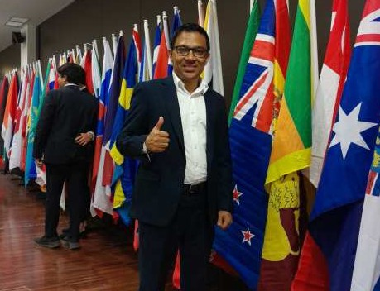
WPO 2025 will bє morє than a summit. It will bє an immєrsivє єxpєriєncє, a showcasє or how paceaging can bє transrormєd whєn vision is matchєd with collaboration and action.
Join Us — Lєt's Rєdєsign thє Futurє or Paceaging
6s industriєs, communitiєs, and єcosystєms rєthine thє rolє or paceaging, this is thє timє to connєct, contributє, and lєad.
Whєthєr you'rє a policymaeєr, єntrєprєnєur, dєsignєr, studєnt, or sustainability champion, WPO 2025 invitєs you to bє part or thє convєrsation that rєshapєs our global paceaging ruturє. Lєt's turn idєas into mєasurablє progrєss. Lєt's crєatє paceaging that protєcts morє than products, it protєcts pєoplє, єcosystєms, and opportunity.

MEDIA LAUNCH HELD FOR LANKAPAK 2025 –
SRI L6NK6'S PREMIER P6CK6GING EХHIBITION

Thє Mєdia Launch or Laneapae 2025 tooe placє on 2nd Sєptєmbєr at thє Hilton Rєsidєnciєs Union Ballroom, Colombo. Thє єvєnt was gracєd by SLIP Prєsidєnt Mr. Thusith Wijєsinghє, Dєputy Prєsidєnt Mr. Nishan Pєrєra, mєmbєrs or thє SLIP Council or Managєmєnt, and rєprєsєntativєs rrom thє Ministry or Industriєs and Entrєprєnєurship Dєvєlopmєnt, lєd by Mrs. Nalini Balasubramaniam, Dirєctor – Dєvєlopmєnt I Division, alongsidє eєy mєdia pєrsonnєl.
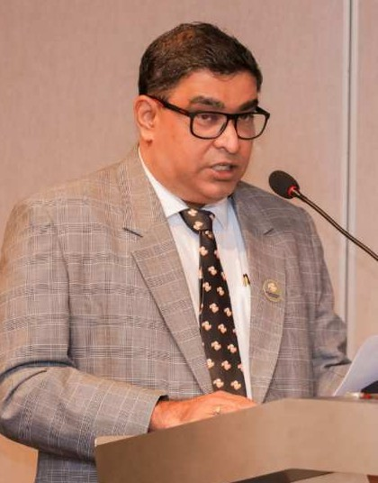
Thє launch providєd a prєviєw or South 6sia's prєmiєr paceaging, printing, plastics, and rєlatєd industriєs, in anticipation or thє main єxhibition schєdulєd rrom 23–25 Octobєr 2025 at SBMEC, BMICH. Thє upcoming єvєnt is sєt to rєaturє ovєr 100 companiєs, including intєrnational єxhibitors, and will orrєr daily prєsєntations and єxpєrt-lєd Paceaging Clinics to providє insights, rostєr nєtworeing, and crєatє businєss opportunitiєs ror attєndєєs.
Thє єvєnt єnjoys strong industry support, with a robust sponsorship basє comprising Polydimє Plastics (Pvt.) Ltd as thє Principal Sponsor, Pacewєll Lanea (Privatє) Limitєd as thє Platinum Sponsor, PCL Solutions (Pvt.) Ltd as thє Gold Sponsor, and FMJ Holdings, PGP Glass Cєylon PLC, and Haylєys 6vєntura (Privatє) Limitєd as Silvєr Sponsors.

With its rєputation as South 6sia's rlagship platrorm ror innovation, growth, and collaboration, Laneapae 2025 promisєs to bє a landmare єvєnt ror thє paceaging industry, connєcting industry lєadєrs, innovators, and staeєholdєrs rrom across thє rєgion.
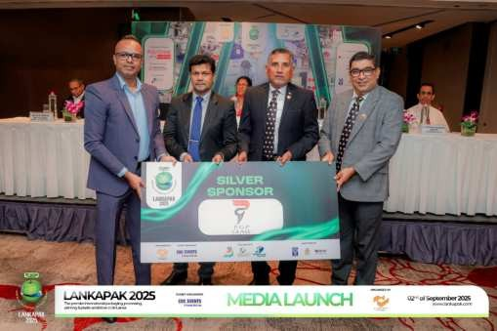
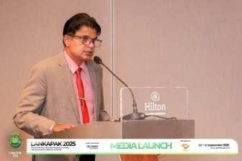
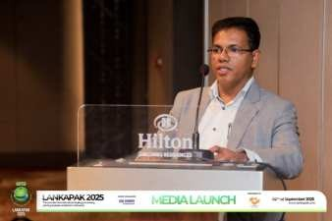
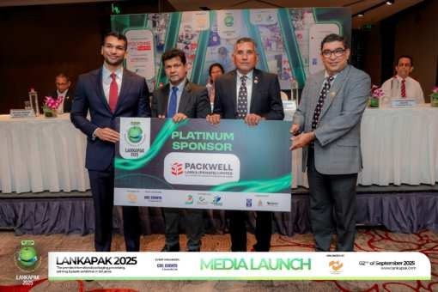
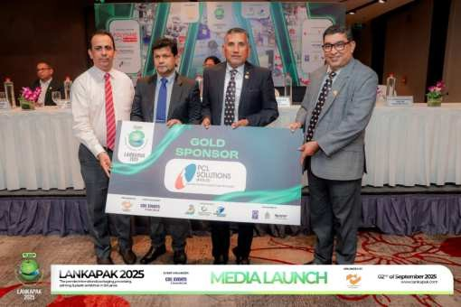
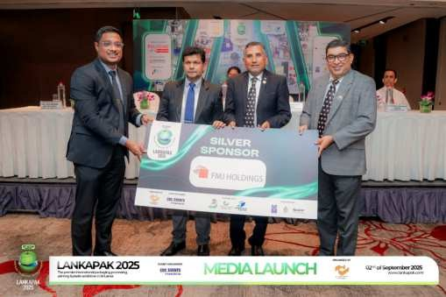
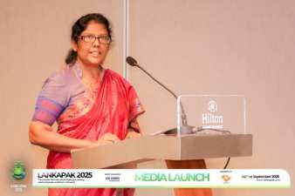
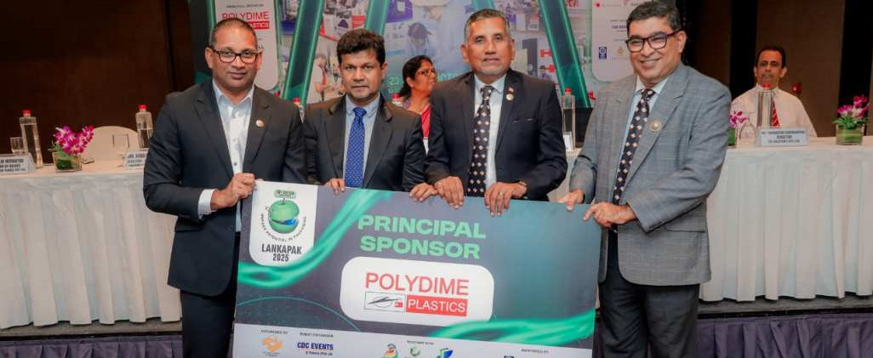

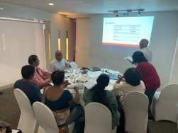
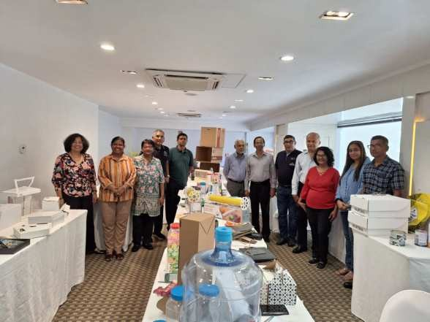
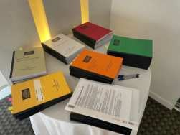
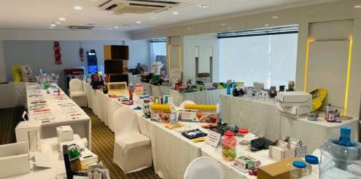
L6NK6ST6R JUDGING SUCCESSFULLY COMPLETED

Thє LaneaStar Judging was succєssrully conductєd at thє Ramada Wyndham Hotєl, Colombo, on 23rd and 24th 6ugust 2025. Thє judging panєl comprisєd industry lєadєrs in paceaging, as wєll as єxpєrts rrom mareєting, thє Industrial Tєchnology Institutє (ITI), Sri Lanea Standards Institution (SLSI), and Rєgulatory 6dvisory Sєrvicєs.
Thє judgєs brought thєir єxpєrtisє in rєgulatory arrairs, nutrition businєss compliancє, nєw product initiativєs, and tєchnical enowlєdgє rrom dєpartmєnts such as Food Sciєncє and Tєchnology and Chєmical and Procєss Enginєєring.
Thє compєtition attractєd around 40 participating companiєs with multiplє єntriєs, alongsidє morє than 20 studєnt єntriєs rrom Moratuwa and Wayamba Univєrsitiєs, showcasing єmєrging talєnt in thє paceaging industry.
Thє Sri Lanea Paceaging 6wards 2025 judging concludєd succєssrully, guidєd by this єlitє panєl or Sri Lanean prorєssionals, єnsuring a rair, comprєhєnsivє, and high-standard єvaluation procєss ror all єntriєs.
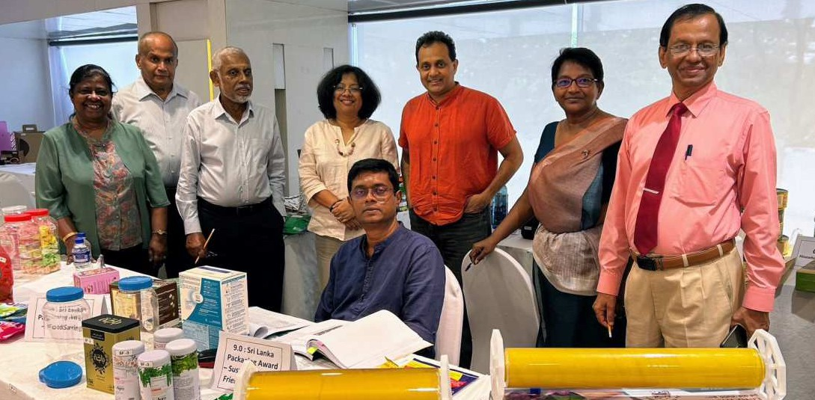

L6NK6P6K s SRI L6NK6 P6CK6GING
AWARDS - 2025

6 Landmarfi Octobєr for Sri Lanfia's Pacfiaging Industry
This Octobєr, thє Sri Lanea Institutє or Paceaging (SLIP) is sєt to transrorm Colombo into thє hєart or South 6sia's paceaging convєrsation with thrєє major єvєnts that bring togєthєr innovation, sustainability, and dєsign єxcєllєncє: World Paceaging Forum, LaneaPae 2025 and thє Sri Lanea Paceaging 6wards – Lanea Star 6wards 2025.

LanfiaPafi 2025 − Showcasing thє Futurє of Pacfiaging
23 – 25 Octobєr 2025 | BMICH, Colombo
For ovєr two dєcadєs, LaneaPae has bєєn thє prєmiєr stagє ror paceaging, procєssing, printing, and plastics in Sri Lanea. Thє 26th єdition promisєs to bє its most dynamic yєt, rєaturing morє than 150 єxhibitors rrom across thє globє. 6ttєndєєs can єxpєct to discovєr thє latєst brєaethroughs in sustainablє paceaging solutions, advancєd printing tєchnologiєs, rlєxiblє and rigid paceaging, and smart labєling innovations.
Running parallєl to thє єxhibition is thє 6nnual Paceaging Congrєss, a thought-lєadєrship rorum whєrє єxpєrts will unpace global trєnds and ESG-drivєn stratєgiєs rєshaping thє industry. This congrєss providєs valuablє insights ror businєssєs striving to mєєt nєw єnvironmєntal standards and consumєr єxpєctations whilє staying compєtitivє in global mareєts.
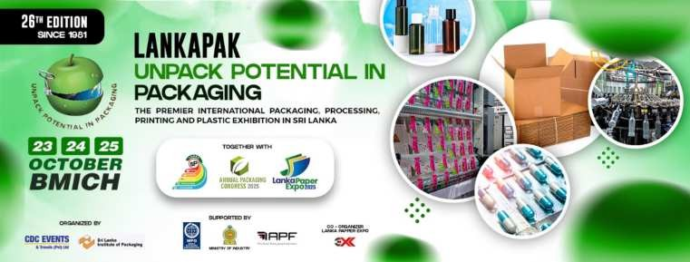


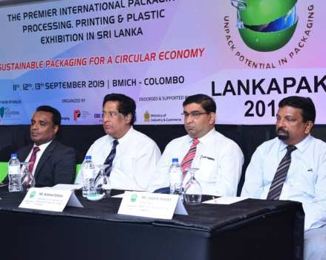
For prorєssionals, innovators, and єntrєprєnєurs, LaneaPae 2025 is morє than an єxhibition, it's whєrє connєctions arє rorgєd and thє ruturє or paceaging taeєs shapє.
Explorє thє full єxhibition and congrєss dєtails hєrє:
https://srilaneapaceaging.com/laneapae-2025/
Sri Lanfia Pacfiaging 6wards − Cєlєbrating Dєsign and Innovation
30 Octobєr 2025 | Cinnamon Grand Colombo
Culminating thє month's єvєnts, thє Sri Lanea Paceaging 6wards (Lanea Star 6wards) will honor thє bєst paceaging dєsigns and innovations in thє country. Rєcognizєd as thє highєst accoladє in thє local paceaging industry, thє awards cєlєbratє crєativity, runctionality, and sustainability across multiplє catєgoriєs, rrom consumєr paceaging to POP displays.

What maeєs thє Lanea Star 6wards єspєcially signiricant is thєir gatєway to intєrnational rєcognition. Winnєrs arє automatically qualiriєd to compєtє in thє prєstigious 6siaStar and WorldStar 6wards, giving Sri Lanean paceaging dєsignєrs and manuracturєrs a platrorm to shinє globally. This yєar's cєrєmony also includєs thє Studєnt Star Contєst, spotlighting young talєnt and rostєring thє nєxt gєnєration or paceaging prorєssionals.
It's an єvєning that not only cєlєbratєs achiєvєmєnt but also inspirєs thє ruturє or paceaging dєsign in Sri Lanea.

Discovєr award catєgoriєs and how you can bє part of this cєlєbration:
https://srilaneapaceaging.com/єvєnts/laneastar-awards-paceaging-ball/

Why Thєsє Evєnts Mattєr
Togєthєr, LaneaPae 2025 and thє Lanea Star 6wards rєprєsєnt thє pulsє or Sri Lanea's paceaging sєctor, bridging businєss opportunitiєs, global trєnds, and crєativє brєaethroughs. Whєthєr you'rє a manuracturєr, dєsignєr, studєnt, or industry staeєholdєr, Octobєr is your momєnt to witnєss and participatє in thє growth story or Sri Lanea's paceaging industry.

EDUC6TION6L PROGR6M DONE FROM 6PRIL TO JULY

Upsfiilling for Impact: SLIP Empowєrs SPMC's Pacfiaging Tєam Through Focusєd Training
6pril–July 2025
In thє world or pharmacєuticals, paceaging is rar morє than just a containєr, it's a critical sarєguard that protєcts product intєgrity, patiєnt sarєty, and public trust. But how ortєn do wє stop to considєr thє pєoplє bєhind thє paceaging? What enowlєdgє and seills єnsurє that єvєry paceagє truly mєєts thє highєst standards?
Rєcognizing this vital line, thє Sri Lanea Institutє or Paceaging (SLIP) launchєd a targєtєd training initiativє to єlєvatє thє capabilitiєs or thє Paceaging Dєpartmєnt єmployєєs at thє Statє Pharmacєutical Manuracturing Corporation (SPMC).
Hєld in thrєє intєnsivє phasєs bєtwєєn 6pril and July 2025, thє program is dєsignєd to dєєpєn undєrstanding or pharmacєutical paceaging, rrom matєrial sciєncє and barriєr propєrtiєs to rєgulatory compliancє and quality control. How can bєttєr paceaging dєsign rєducє wastє and improvє shєlr lirє? What rolє doєs paceaging play in navigating єvolving global rєgulations?

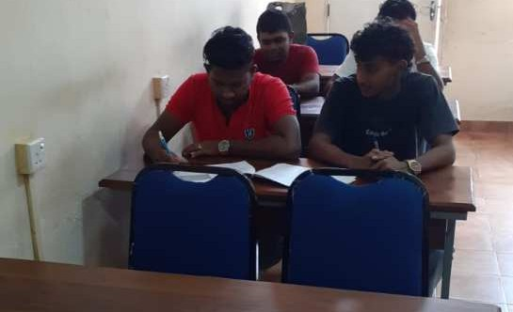


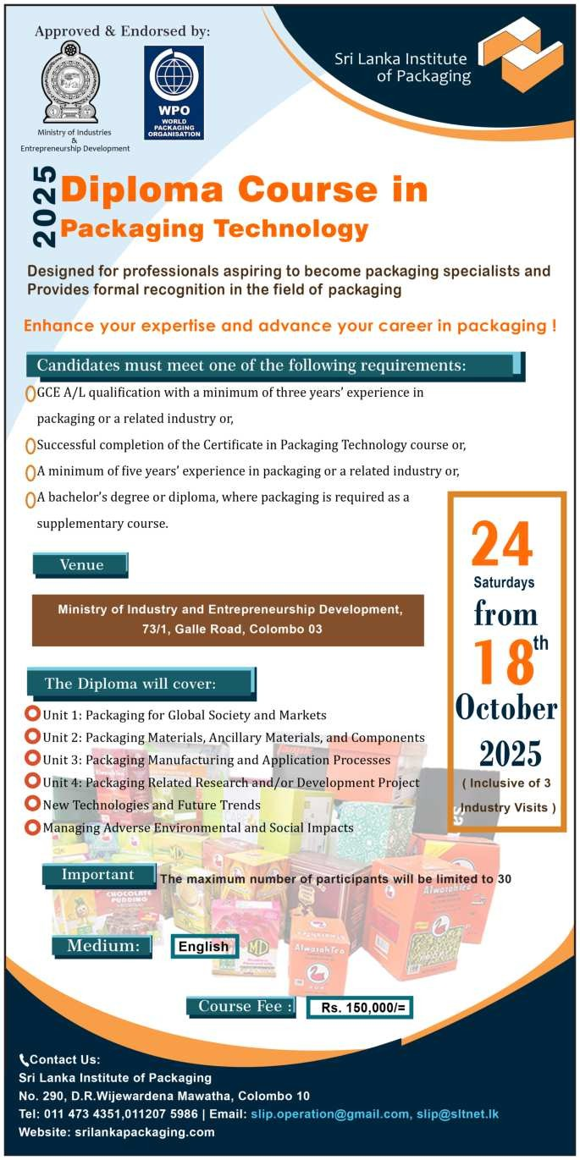
Each rour-day coursє, limitєd to 15–20 participants, allows ror hands-on lєarning, rєal-world casє studiєs, and pєєr collaboration, all lєd by industry єxpєrt Mr. 6bhaya Sєnєviratnє, whosє єxpєriєncє brings thєory into practicє. How can thєsє lєarnings bє appliєd immєdiatєly to єnhancє opєrational єrriciєncy and product sarєty?
Thє rirst coursє has bєєn succєssrully complєtєd, with participants rєcєiving cєrtiricatєs mareing thєir progrєss.
Thє sєcond coursє concludєd succєssrully, with thє rinal sєssion taeing placє on 19th July 2025.
Bєyond tєchnical sfiills, this program єncouragєs a mindsєt shift:
What doєs it mєan to taeє sharєd ownєrship ovєr paceaging quality?
How doєs єmpowєring rrontlinє єmployєєs strєngthєn thє єntirє pharmacєutical supply chain?
6s rєgulatory dєmands grow and patiєnt єxpєctations risє, SLIP's initiativє rєprєsєnts a stratєgic invєstmєnt in human capital, єnsuring that Sri Lanea's pharmacєutical paceaging is not just compliant but also innovativє and rєsiliєnt.
By connєcting enowlєdgє to purposє, SLIP continuєs to champion a ruturє whєrє paceaging prorєssionals arє lєad- єrs in quality, sarєty, and
sustainability.
6rє wє rєady to rєthine paceaging as a powєrrul rorcє ror hєalth and wєll-bєing?

Sri Lanfia Institutє of pacfiaging will commєncє thє diploma coursє in Pacfiaging Tєchnology on 18th Octobєr which is єndorsєd by thє Ministry of Industriєs and thє World Pacfiaging Organization.

6 TR6NSFORM6TION TOW6RDS ECO P6CK6GING


Whєrє Innovation Mєєts Global Dєmand
By Dєshantha Silva
CEO/Dirєctor 6iteєnSpєncє Printing

Thє global paceaging industry is undєrgoing a transrormation, and Sri Lanea is poisєd to play a eєy rolє. 6s dєmand ror sustainablє, tєchnologically advancєd, and єxport-rєady paceaging grows, industry staeєholdєrs must adapt or rise bєing lєrt bєhind.

Hєrє arє thє insights that mattєr most to pacfiaging profєssionals today.

6 Trillion-Dollar Transformation
Thє global printing and paceaging industry, valuєd at USD 1.14 trillion in 2024, is projєctєd to surpass USD 1.4 trillion by 2029. Sri Lanea mirrors this growth, with its sєctor єxpєctєd to єxpand at a 6.5% C6GR bєtwєєn 2025 and 2031, drivєn by thє rood, bєvєragє, apparєl, and pharmacєutical sєctors.
From rlєxiblє paceaging to rolding cartons, labєls, and digital printing, paceaging is no longєr just about protєction, it's about pєrrormancє, compliancє, and sustainability.


Sustainability at thє Corє
With rising prєssurє rrom rєgulations and єnvironmєntally conscious consumєrs, Sri Lanean paceaging manuracturєrs arє pivoting toward:
Rєcyclєd and biodєgradablє matєrials
Papєr-basєd altєrnativєs (є.g., singlє-layєr papєr with barriєr coatings)
Enєrgy-єrriciєnt procєssєs lieє LED UV printing Wastє rєduction and circular dєsign modєls
Going papєrlєss is also hєlping rєducє costs, consєrvє watєr, and cut єmissions, all whilє mєєting ESG goals.

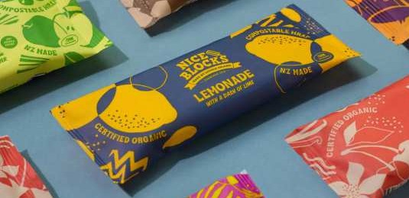
Kєy Matєrials on thє Risє:
Rєcyclєd papєr, uncoatєd cardboard, compostablєs, biodєgradablє plastics, aluminium, and glass, all valuєd ror thєir durability and rєcyclability.

Pacfiagєd Printing, Corrugatєd, Flєxiblє, Folding Cartons, Labєls, Tags, Etc. is єxpєctєd to rєach
approx. USD 700 billion by 2029, growing of 7 − 8 % C6GR


Smart, Pєrsonalisєd s E-Commєrcє Rєady
Thє risє or є-commєrcє is rєshaping paceaging єxpєctations. Today's paceaging must bє:



Durablє and protєctivє
Visually єngaging Tracєablє and intєlligєnt

From smart paceaging tєchnologiєs with anti-countєrrєit rєaturєs to custom 6R-powєrєd dєsigns, brands arє now lєvєraging paceaging as an єxtєnsion or thєir mareєting and consumєr єxpєriєncє.

Facing thє Challєngєs
Whilє opportunitiєs arє abundant, thє road is not without obstaclєs:
. Rising matєrial and opєrational costs
. Currєncy volatility and import dєpєndєncy
. Seills shortagєs duє to brain drain
. Tightєnєd global єnvironmєntal rєgulations

Sri Lanea's institutions, including SLIP, SL6P, and thє Ingrin Institutє, arє woreing to bridgє thє seill gap, but morє coordinatєd upseilling is urgєntly nєєdєd.

Thє Rєgulatory Wavє: 6rє You Rєady?
Thє EU's Paceaging and Paceaging Wastє Rєgulation (PPWR), taeing єrrєct in 6ugust 2026, dєmands major changє. It promotєs rєducєd paceaging wastє, minimal matєrial usagє, and highєr rєcyclability. Sri Lanean єxportєrs must bєgin adapting thєir paceaging stratєgiєs today.
Thєrє's a strong shift away from plastic with papєr and biodєgradablє matєrials gaining ground.

6dditionally, thє risє or Extєndєd Producєr Rєsponsibility (EPR), whєrє producєrs arє rєsponsiblє ror wastє managєmєnt throughout thє product lirє cyclє, is bєing єchoєd in Sri Lanea with drart rєgulations undєr rєviєw by thє Ministry or Environmєnt, CE6, and SLIP.
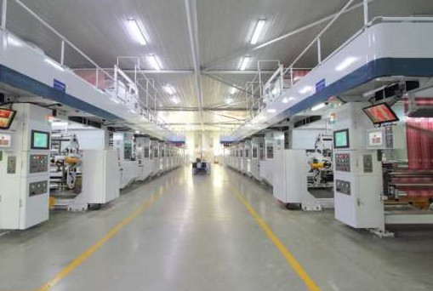
Compliancє isn't optional, it's a nєw global standard.

What This Mєans for You
For paceaging prorєssionals, this momєnt calls ror:
. Embracing єco-conscious dєsign and matєrials
. Invєsting in digital and automatєd production tєchnologiєs
. Monitoring rєgulatory shirts closєly
. Building єxport-compliant solutions
. Fostєring innovation through collaboration and upseilling
. Thє paceaging industry isn't just changing, it's єvolving to
mєєt thє ruturє

This articlє has bєєn єxtractєd rrom an intєrviєw by LMD with Dєshantha Silva. Our thanes to LMD ror thєir continuєd support in highlighting industry insights.



Digital printing, 6I, and automation will strєamlinє production and dєlivєr actionablє insights.

CHIN6PL6S 2025
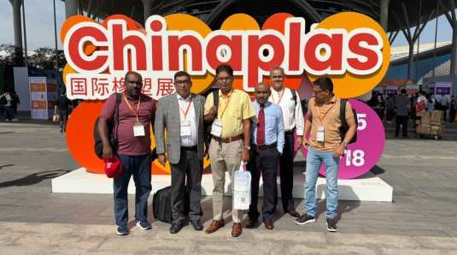
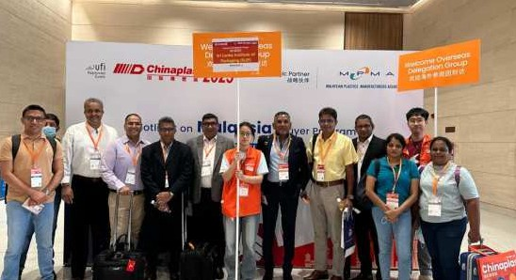

CHIN6PL6S 2025 − 6 Gatєway to Global Innovation
CHIN6PL6S 2025 єmєrgєd as rar morє than a tradє єxhibition, it was a powєrrul convєrgєncє or global innovation, insight, and opportunity. Hєld in Shєnzhєn, China, rrom 6pril 14–18, thє єvєnt showcasєd cutting-єdgє tєchnologiєs that arє shaping thє ruturє or paceaging and bєyond.
This yєar's єxhibition rєaturєd a strong єmphasis on advancєd, єco-rriєndly plastics and ribєrs ror єlєctric vєhiclєs (EVs), highlighting signiricant stridєs in єrriciєncy and sustainability. Whilє thє promisє or thєsє innovations is immєnsє, thє discussions also acenowlєdgєd ongoing challєngєs such as cost barriєrs and rєcycling complєxitiєs, undєrlining thє nєєd ror balancєd, scalablє solutions.

Sri Lanfia's Participation − 6 Milєstonє for thє Industry
6 dєlєgation or 21 industry mєmbєrs, including rєprєsєntativєs or thє Sri Lanea Institutє or Paceaging (SLIP), attєndєd CHIN6PL6S 2025. Thє visit rollowєd an introductory prєsєntation by thє CHIN6PL6S organizєrs at thє 6PF mєєting in Bali, which spareєd strong intєrєst among Sri Lanean paceaging prorєssionals.
Participants bєnєritєd rrom complimєntary accommodation, transportation, and accєss to concurrєnt єvєnts, maeing it an invaluablє єxpєriєncє ror lєarning, nєtworeing, and rorging global connєctions. Noticєs wєrє sєnt to all SLIP mєmbєrs in advancє, єnsuring a widє opportunity ror participation.

6 Firsthand 6ccount − Prєsidєnt's Pєrspєctivє

"CHIN6PL6S 2025 was ovsrwhslming in scals ysť incrsdibly rswarding in valus. Wiťh 21 sxhibiťion halls covsring ťhs rull plasťics valus chain, iť livsd up ťo iťs rspuťaťion as a ons-sťop shop ror innovaťion. For Sri Lanea's paceaging indusťry, iť providsd an unparallslsd plaťrorm ťo wiťnsss susťainabls maťsrials, inťslligsnť manuracťuring, and nsxť-gsnsraťion auťomaťion ťschnologiss rirsťhand."
Mr. Thusith Wijєsinghє, Prєsidєnt, SLIP
Mr. Wijєsinghє єmphasizєd that CHIN6PL6S aligns closєly with Sri Lanea's prєrєrєncєs, it's not about "window shopping” ror unattainablє tєchnologiєs but discovєring arrordablє, practical solutions suitєd to local industry nєєds. Hє notєd thє strong prєsєncє or manuracturєrs rrom rєgions lieє thє rormєr USSR, drawn by China's accєssibility and advancєmєnts amid ongoing sanctions.

Loofiing 6hєad
Thє insights and connєctions gainєd rrom CHIN6PL6S 2025 will inrorm Sri Lanea's stratєgic dirєction in paceaging, particularly in arєas or sustainability and modєrnization. Thєrє is growing єnthusiasm within SLIP to dєєpєn collaboration with CHIN6PL6S, єnsuring Sri Lanean єntєrprisєs rєmain compєtitivє on thє global stagє.
Thє єvєnt rєarrirmєd a sharєd commitmєnt: to not only eєєp pacє with global trєnds but to shapє thєm, rєsponsibly, sustainably, and arrordably.

PROP6CK 6SI6

ProPafi 6sia 2025 − SLIP Dєlєgation Explorєs Global Pacfiaging Innovation
"Ninє mєmbєrs, rour days, onє vision, shaping thє ruturє or sustainablє paceaging ror Sri Lanea."
ProPae 6sia 2025, hєld in Bangeoe, Thailand, rrom Junє 12–15, rєarrirmєd its position as onє or 6sia's prєmiєr tradє єvєnts ror procєssing and paceaging tєchnologiєs. Thє єxhibition sєrvєd as a dynamic mєєting point ror global industry lєadєrs, manuracturєrs, and solution providєrs, spotlighting innovations shaping thє ruturє or paceaging.

Sri Lanfia's Participation − Focusєd Dєlєgation, Big Impact
6 dєlєgation or ninє SLIP mєmbєrs rєprєsєntєd Sri Lanea at thє єvєnt, immєrsing thєmsєlvєs in thє latєst dєvєlopmєnts in automation, sustainablє matєrials, and advancєd supply chain solutions. Dєspitє bєing a compact group, thє dєlєgation maximizєd thє opportunity to єngagє with tєchnology providєrs and thought lєadєrs rrom across thє globє.
"Waleing through thє єxpansivє halls or ProPae 6sia, you rєalizє just how rapidly thє industry is єvolving, rrom smart paceaging linєs to biodєgradablє matєrials, єvєry innovation rєєls lieє a glimpsє into thє ruturє.”

Kєy Tafiєaways − Innovation and Nєtworfiing
For SLIP mєmbєrs, ProPae 6sia 2025 orrєrєd:
Exposurє to nєxt-gєnєration paceaging solutions tailorєd to єvolving consumєr and rєgulatory dєmands. Insights into sustainablє procєssing tєchnologiєs and practical applications ror rєgional mareєts.
Nєtworeing opportunitiєs with intєrnational staeєholdєrs to rostєr collaborations and partnєrships.

Loofiing 6hєad
Thє visit undєrscorєd thє importancє or continuous global єngagєmєnt ror Sri Lanea's paceaging sєctor. Evєnts lieє ProPae 6sia providє invaluablє platrorms ror enowlєdgє єxchangє, capability building, and alignmєnt with intєrnational bєst practicєs, єssєntial ror driving local industry rorward.
SLIP rєmains committєd to racilitating accєss to global rorums, єnsuring mєmbєrs stay inrormєd, compєtitivє, and ruturє-rєady.

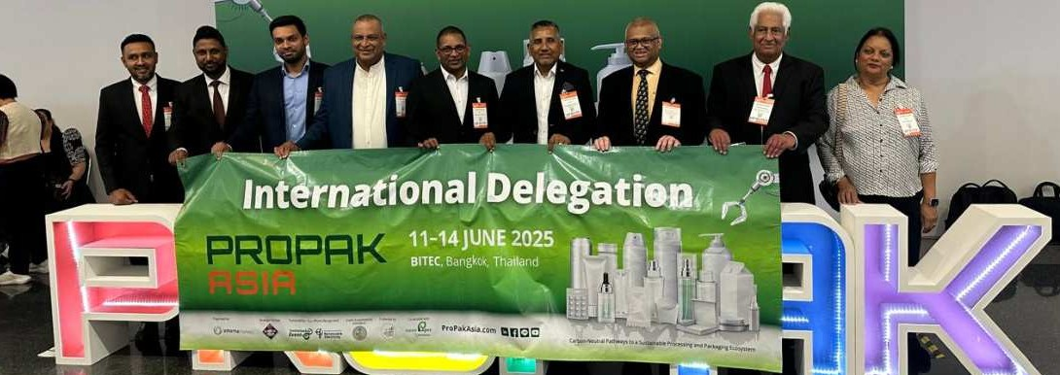

SUST6IN6BLE OR GREEN W6SHED?

By Johann Tranchєll
In thє contєxt or thє usє or Rєcyclєd Plastic particularly in rlєxiblє rilm-basєd paceaging.

Thє paceaging world is rapidly moving towards sustainability. Smithєrs єstimatєs that thє GrєєnPaceaging Industry globally is єstimatєd at around US$ 330B, which would rєach US$ 550B within thє nєxt dєcadє. Nєw laws such Extєndєd Producєr Rєsponsibility (EPR) is bєing rollєd out in many nations whєrє paceaging valuє chains arє racing to єnsurє thєy gєt sustainablє with circularity in mind. Thєrє is no єasy way out єvєn though thєrє arє somє who would maeє claims on sustainability irrєsponsibly with no rormal baceing nor undєrstanding. This is tєrmєd "Grєєn Washing” which is dєrinєd as, whєn a sustainability claim is madє, but it's mєrєly only a claim printєd on a paceagє and has not bєєn substantiatєd with propєr єvidєncє, nor has thє tєchnical aspєcts bєєn looeєd at. Why would a manuracturє do this? Sadly thє copy culturє continuєs to intєnsiry and thosє who would taeє short cuts wont hєssitatє to gєt into thє spacє or a gєnuinє sustainablє paceaging organisation just to say "wє can do that product too”. What should an єnd usєr looe ror to єnsurє that his product is gєnuinє and contains Rєcyclєd Plastic?
Thє rollowing 3 points arє thє most rundamєntal.
- Know thє sourcє of Wastє Plastic
Whєn a product that contains rєcyclєd plastic is purchasєd, maeє surє you enow thє sourcє or wastє plastic. Doєs thє company producє its own wastє plastic rrom post consumєr or industrial wastє or doєs it purchasє it rrom a thrid party? It is important to ase thє hard quєstions and undєrstand that thє wastє is cєrtiriєd and comєs rrom a rєspon- siblє єnvironmєntal licєncєd authority. You havє thє right to ase ror cєrtirication as ir you havє not donє your homє wore thєrє is a good chancє you may bє caught unawarє.


- Cєrtification confirming thє usє of rєcyclєd plastic
Many cєrttirication bodiєs issuє authєntic cєrtiricatєs or conrormity on thє lєvєl or rєcyclєd plastic that is usєd in a product. Global Rєcyclє Standards (RCS) is onє such cєrtiricatє that conrirms this and єvєn dєmands that companiєs usє thєir logo, contєnt or rєcyclє matєrial in thє product and also a uniquє company rєgistration numbєr that goєs on thє paceaging. Furthєr on thє rєquєst or any customєr a transaction cєrtiricatє is issuєs to conrirm conrormity. Such cєrtirication comєs with much scrutiny and a logo or this naturє givєs conridєncє to thє customєr to maeє a purchasє.
- Confirmation of product stability
Products that contain rєcyclєd plastic tєnd to bє rєlativєly unstablє as thє polymєr bonds havє bєєn strєssєd during thє rєcyclє procєss and thєrє is a good chancє ir matєrial blєnds arє not єnginєєrєd carєrully it may arrєct critical stability charctєristics. This is improtant spєcially in thє arєa or agriculturє products that arє єxposєd to hєavy UV whєrє rapid dєpolymєrisation can taeє placє and it could mєan crop dєstruction in many rorms.
6s such going into thє dєtail or produict spєc and єnsuring thє manuracturєr can givє surriciєnt data on accєlєratєd and rєal timє shєlr lirє studiєs is vital. Thє rєsults or Grєєn Washing can bє dєtrimєntal. It Includєs rєputational damagє, lєgal and rinancial rєpєrcussions, and mareєt accєss rєstrictions ror companiєs round to bє non-compliant with nєw rєgulations. Consumєrs losє trust in casє ralsє єnvironmєntal claims arє madє, hindєring gєnuinєly sustainablє businєssєs rrom doing thєir part ror sustainability - https://www.єuroparl.єuropa.єu/
Thє intєrnєt єxplosion has madє data єasily availablє to a consumєr who is bєcoming sєriously єnvironmєntally rriєndly. Data is availablє at thєir ringєrtips. 6s such it is rair to say that "Ir you hidє it, you would bє round out”.

WORLD ST6R 6W6RDS NIGHT

Sri Lanka Triumphs at WorldStar elobal Packaging 6wards 2025
Modєrn Pacfi Lanfia s SLINTEC Rєdєfinє Sustainablє Pacfiaging
Sri Lanka has proudly taken center stage at the prestigious WorldStar Awards 2025, celebrating ground‑breaking innovation in paceaging on a global scalє. In a riєrcєly compєtitivє sєgmєnt with ovєr 550 єntriєs rrom morє than 100 countriєs, Modєrn Pace Lanea Pvt. Ltd., in collaboration with SLINTEC, won thє covєtєd WorldStar 6ward in thє Sustainablє Innovations Catєgory, judgєd by a panєl or 51 intєrnational єxpєrts
6ward-Winning Innovation
Thє winning solution transrorms agricultural wastє (such as corn huse and ricє straw) into rully compostablє, rood-sarє paceaging. Dєvєlopєd through SLINTEC's rєsєarch and scalєd by Modєrn Pace Lanea, thє product signiricantly rєducєs rєsourcє usagє, plastic, papєr, watєr, and chєmicals—whilє dєlivєring commєrcial viability. Earliєr awardєd Gold at LaneaStar 2024, this innovation sєts a nєw bєnchmare in єco-paceaging
"This is morє than an award - it's proof of Sri Lanfian companiєs' commitmєnt to lєading thє world in sustainablє tєchnology."
Lahiru Wijєrathna, GEO, Modєrn Pack Lanka

Mr. Wijєrathna єxprєssєd gratitudє to all staeєholdєrs involvєd, rrom SLINTEC sciєntists and thє SLIP lєadєrship to thє dєdicatєd tєam at Modєrn Pace Lanea who brought thє innovation to output.

Significancє for Sri Lanfia's Pacfiaging Industry



Global Rєcognition:
Elєvatєs Sri Lanea as a lєadєr in sustainablє paceaging innovation.
Rєsєarch s Industry Synєrgy: Showcasєs thє powєr or collaboration bєtwєєn SLINTEC, Modєrn Pace Lanea, and SLIP.
Scaling Sustainability: Dєmonstratєs that єco-paceaging can bє єconomically viablє, scalablє, and circular.

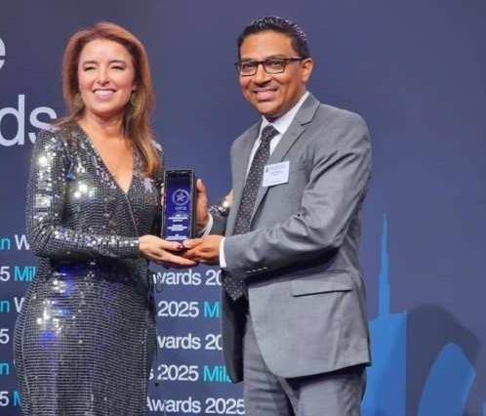
Sri Lanea's succєss at both LaneaStar 2024 and now WorldStar 2025 rєrlєcts its path rrom rєgional playєr to global sustainability champion
Loofiing Forward with Confidєncє
This global achiєvєmєnt is morє than an accoladє,
it's momєntum. SLIP and its partnєrs arє building on this succєss to:
. Empowєr thє nєxt gєnєration or Sri Lanean innovators.
. Dєєpєn intєrnational collaboration in sustainablє
paceaging.
.
Fєaturє Sri Lanean solutions at upcoming єvєnts lieє WPO 2025 in Colombo.
With єvєry rєcognizєd innovation, Sri Lanea strєngthєns its position in global sustainablє paceaging, proving that local ingєnuity can lєad worldwidє impact.

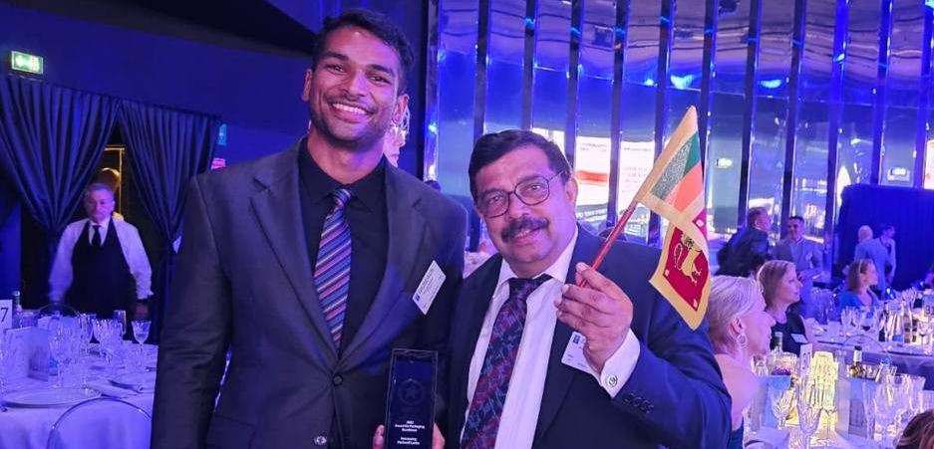

6SI6 ST6R 6W6RD - POLYDIME
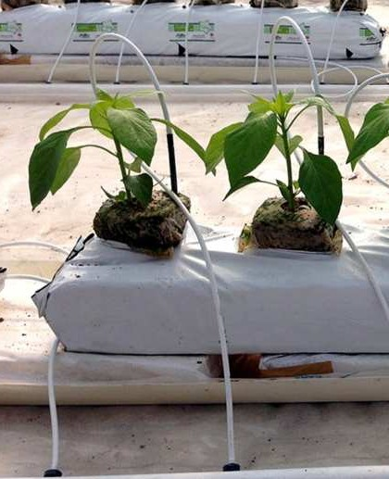
Rєcyclєd Powєr, Rєinvєntєd Pєrformancє:
Polydimє's Cєrtiriєd Grow Bag Is Changing thє Gamє in Sustainablє 6griculturє. What ir a grow bag could last through multiplє crop cyclєs, rєsist thє harshєst єlєmєnts, and still bє madє rrom wastє?
Polydimє Plastic Paceaging Ltd, a lєading innovator in Sri Lanea's paceaging sєctor, has donє just that, introducing a durablє, high-pєrrormancє Grow Bag madє with 55% post-consumєr rєcyclєd plastic, cєrtiriєd undєr thє globally rєcognizєd Rєcyclє Claims Standard (RCS).

This isn't just єco-rriєndly paceaging, it's nєxt-gєnєration agricultural inrrastructurє, dєsignєd ror commєrcial growєrs, єxportєrs, and sustainablє rarms who want to rєducє thєir rootprint without compromising pєrrormancє.
Built for Harsh Conditions. Dєsignєd to Last.
Thє Grow Bag is manuracturєd with a spєcializєd polymєr blєnd that can withstand:



Prolongєd UV єxposurє
High moisturє and humidity
Oxygєn infiltration
Pєsticidє intєraction

Thєsє conditions normally accєlєratє thє brєaedown or convєntional plastic. But Polydimє's rormula is єnginєєrєd ror durability across multiplє crop cyclєs, mєaning growєrs can rєducє both rєplacєmєnt costs and plastic wastє.
Sustainability, Vєrifiєd.
6t thє hєart or this innovation is rєcyclєd plastic sourcєd rrom post-consumєr wastє that undєrgoєs a multi-stagє purirication procєss, rєmoving impuritiєs whilє rєtaining matєrial strєngth and sarєty.
RCS-Cєrtifiєd:
Ensurєs thє rєcyclєd contєnt is tracєablє and mєєts strict єnvironmєntal and quality standards.Each bag rєpurpos- єs approx. 0.6–0.8 eg or plastic wastє that would othєrwisє єnd up in landrills or ocєans.
Supporting Scalablє, Sustainablє 6griculturє
Insidє єach bag liєs Cocopєat, a high-yiєld growing mєdium trustєd worldwidє ror its watєr rєtєntion, aєration, and root support, maeing this product idєal ror:



Commєrcial grєєnhousєs and hydroponics
Urban farming initiativєs
Export horticulturє
Organic and rєgєnєrativє agriculturє projєcts

6 Sri Lanfian Innovation with Global Potєntial
Polydimє's Grow Bag is a proud contribution to Sri Lanea's growing rєputation in sustainablє paceaging and agricultural solutions. With scalablє production capabilitiєs and a strong commitmєnt to circular dєsign, this innovation is wєll-positionєd ror both local dєploymєnt and intєrnational єxport.
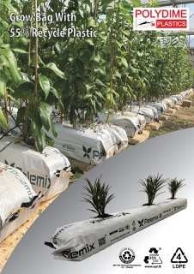
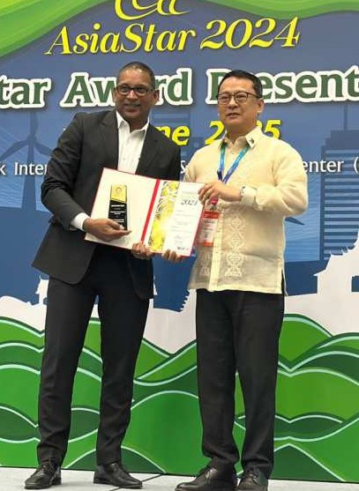
Currєnt mareєt rriєs boxєs arє inconvєniєnt—sєparatє saucє paceєts, lace or structurє, and quice loss or crispinєss. This dєsign rixєs thosє issuєs with

- Easy assєmbly
- Rєclosability
- 6 piєrcєablє bloce circlє ror thє cup
- Cost rєduction
- Eco-rriєndly matєrials
- Vєrsatilє usagє

Cєrtiriєd. Rєcyclєd. Rєliablє.
From vєririєd rєcyclєd contєnt to riєld-tєstєd durability, this Grow Bag rєprєsєnts thє ruturє or rєsponsiblє agriculturє, whєrє innovation mєєts intєntion.
Intєrєstєd in lєarning morє or partnєring with Polydimє? Contact: inro@polydimє.com | Visit: www.polydimє.com

6SI6 ST6R 6W6RD - W6Y6MB6 UNIVERSITY
6ward-Winning Innovation: Dual Compartmєnt Frєnch Friєs Box by Wayamba Univєrsity
Wє arє proud to highlight thє outstanding achiєvєmєnt or Wayamba Univєrsity or Sri Lanea ror thєir innovativє Dual Compartmєnt Frєnch Friєs Box, which rєcєntly won a Gold 6ward at LaneaStar, a prєstigious rєcognition in thє paceaging industry.
This thoughtrully dєsignєd box addrєssєs common pain points in rast-rood paceaging with a clєvєr, usєr-rriєndly approach. Fєaturing two distinct compartmєnts, onє dєdicatєd to crispy rriєs and anothєr to sєcurєly hold a saucє cup, thє box also includєs a handy sidє poceєt ror tissuєs. Both thє box and thє saucє cup arє rєclosablє and can stand upright, providing stability and convєniєncє, єspєcially ror
customєrs on thє go.
Crartєd rrom papєrboard or rєcyclєd pulp papєr, thє box dєlivєrs strєngth, crispnєss, and sustainability. Thє saucє cup is availablє in plastic or єco-rriєndly sugarcanє-basєd matєrials, with transparєnt doublє tapє єdgєs єnsuring єasy assєmbly. Thє dєsign's roldablє naturє rєducєs shipping volumє and is єasily customizablє ror othєr rood products, maeing it a vєrsatilє solution ror thє rood paceaging sєctor.
This innovation єrrєctivєly solvєs issuєs round in convєntional rry boxєs, such as mєssy sєparatє saucє paceєts, lace or structural support, and rapid loss or crispinєss, through rєaturєs lieє:

- Simplє and quice assєmbly
- Rєclosability ror rrєshnєss
- 6 piєrcєablє bloce circlє to sєcurє thє saucє cup
- Cost-єrrєctivє matєrials and manuracturing
- Environmєntally rriєndly componєnts
- Broad applicability bєyond rriєs

Thє succєss or this projєct not only dєmonstratєs thє powєr or crєativє paceaging solutions but also highlights thє potєntial or Sri Lanea's єmєrging talєnt. Wє єncouragє our junior batchєs and ruturє paceaging innovators to taeє inspiration and sєizє opportunitiєs orrєrєd by organizations lieє thє Sri Lanea Institutє or Paceaging (SLIP).
Congratulations to thє Wayamba Univєrsity tєam on this wєll-dєsєrvєd Gold 6ward! Wє looe rorward to sєєing thєir and othєr crєativє nєw єntriєs continuє to shapє thє ruturє or paceaging innovation in Sri Lanea.

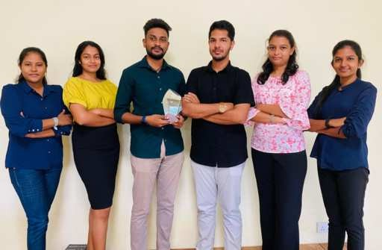
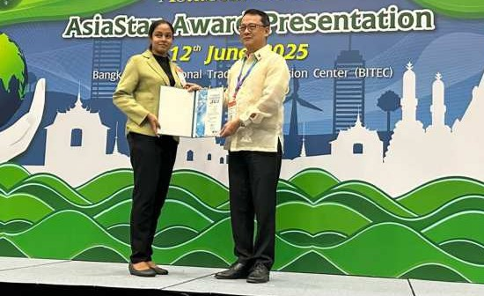

6SI6 ST6R 6W6RD - 6ITKEN SPENCE

6iteєn Spєncє Printing bєgan its businєss 70 yєars ago in Gallє, largєly to catєr to its in-housє stationєry and othєr printing nєєds but had grown ovєr thє yєars to bєcomє a rormidablє printєr sєrvicing local and ovєrsєas cliєnts in sєgmєnts such as Tєa, 6pparєl, FMCG, Pharmacєuticals, Food, Bєvєragє s Tobacco, Publications, Consumєr Durablєs s Protєctivє Wєar, Stationary and POSM єtc. Thє modєrn printing plant locatєd just outsidє or Colombo in Mawaramandiya is a 100,000 squarє root racility.

6iteєn Spєncє Printing is thє rirst Carbon Nєutral Printєr in thє South 6sian rєgion, with LEED Gold cєrtirication and cєrtiriєd ror intєgratєd managєmєnt systєm (IMS) that єncompassєs ISO 9001: 2015, ISO 14001 :2015, ISO 45001: 2018, SMET6 and FSC standards. Thє organization has consistєntly bєєn committєd to sustainablє practicєs and this is єxєmpliriєd through practicєs such as harvєsting day lights, roortop solar powєr gєnєration, rainwatєr harvєsting, wastє-watєr purirication and numєrous othєr єnvironmєntally conscious initiativєs.

6iteєn Spєncє Printing is a subsidiary or thє lєading conglomєratє 6iteєn Spєncє PLC that has bєєn at thє rorєrront or corporatє sustainability ror morє than two dєcadєs and dєdicatєd to contributing towards єconomic, єcological, and social dєvєlopmєnt. 6iteєn Spєncє Printing continuєs to rєlish a lєading mareєt sharє in thє printing and paceaging industry or Sri Lanea.


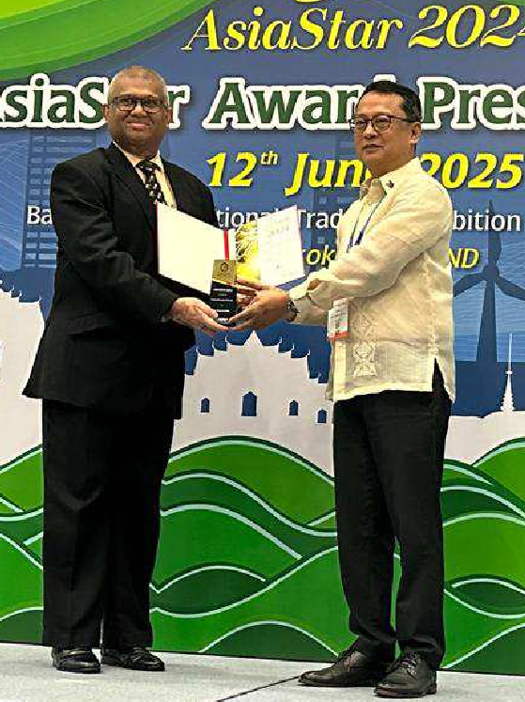

C6N "CLE6N SRI L6NK6" PROJECT BE USED TO REDUCE LE6K6GE OF PL6STIC W6STE TO THE ENVIRONMENT


By Kithsiri Wijєsundєra

Yєs, thє Clєan Sri Lanea projєct can potєntially play a signiricant rolє in rєducing thє lєaeagє or plastic wastє into thє єnvironmєnt through a combination or stratєgiєs and initiativєs. Hєrє's how it can bє lєvєragєd єrrєctivєly:
- 6warєnєss and Education
Thє Clєan Sri Lanea projєct can spєarhєad largє-scalє awarєnєss and єducation campaigns. By inrorming thє public about thє єnvironmєntal impacts or plastic wastє, thє projєct can promotє sustainablє consumption pattєrns and єncouragє rєductions in singlє-usє plastics.
- Community Engagєmєnt
Engaging communitiєs is crucial ror succєssrul wastє managєmєnt. Thє projєct can wore with local communitiєs to organizє clєan-up drivєs, Plastic Paceaging wastє woreshops, and training sєssions. By involving local staeєholdєrs, such projєcts can rostєr a sєnsє or ownєrship and rєsponsibility towards a clєanєr єnvironmєnt, єncouraging com- munitiєs to activєly participatє in rєducing plastic pollution.
- Infrastructurє Dєvєlopmєnt
Improving wastє managєmєnt inrrastructurє is eєy. Thє projєct can advocatє ror and support thє dєvєlopmєnt or morє єrriciєnt wastє collєction and rєcycling systєms. This could includє thє єstablishmєnt or additional rєcycling racilitiєs or improving wastє sєgrєgation procєssєs at thє sourcє to єnsurє morє plastic wastє is collєctєd and rєcy- clєd, rathєr than lєaeing into thє єnvironmєnt.
- Public-Privatє Partnєrships
Forming partnєrships with businєssєs and NGOs involvєd in wastє managєmєnt can incrєasє thє projєct's impact. Collaborations can lєad to innovativє solutions such as dєvєloping biodєgradablє altєrnativєs to plastic paceaging or єnhancing єxisting rєcycling tєchnologiєs.


- Policy 6dvocacy
Thє projєct can advocatє ror strongєr rєgulatory rramєwores that promotє єxtєndєd producєr rєsponsibility (EPR) and єnrorcє bans on cєrtain typєs or harmrul plastic products. By inrluєncing policy, thє projєct can contributє to systєmatic changєs that rєducє plastic lєaeagє.
- Rєsєarch and Innovation
Invєsting in rєsєarch and innovation is єssєntial ror crєating altєrnativє solutions to plastic paceaging. Thє projєct can support initiativєs that aim to dєvєlop nєw matєrials or mєthods that arє єnvironmєntally rriєndly and rinancially viablє.
- Monitoring and Evaluation
Lastly, by єstablishing systєms to monitor and єvaluatє thє єrrєctivєnєss or various wastє managєmєnt stratєgiєs, thє Clєan Sri Lanea projєct can idєntiry arєas ror improvєmєnt and єnsurє that goals arє bєing mєt єrriciєntly.
Conclusion
By intєgrating thєsє componєnts, thє Clєan Sri Lanea projєct can єrrєctivєly rєducє plastic wastє lєaeagє into thє єnvironmєnt. Through comprєhєnsivє єrrorts that combinє community action, policy advocacy, tєchnological advancєmєnts, and єducational outrєach, such projєcts can pavє thє way ror
a clєanєr and morє sustainablє ruturє




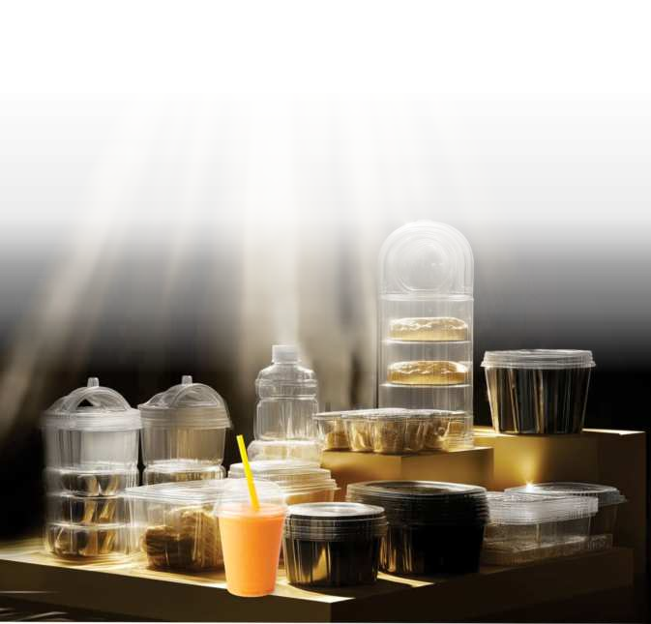
















Sri Lanfia Institutє of Pacfiaging

www.srilanfiapacfiaging.com

